Name: Siron Prajapati Date: 2025/04/14
Semester 2, Level 3 Computing Section ‘A’
1.Create a null vector of size 10 but the fifth value which is 1.
Screenshot
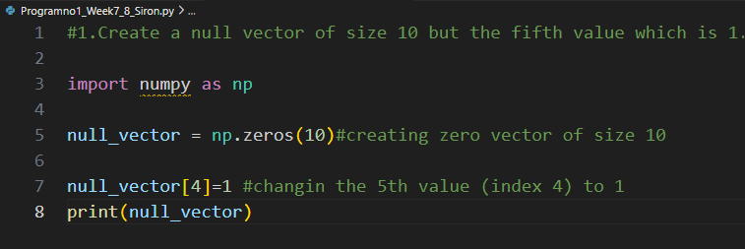
Output

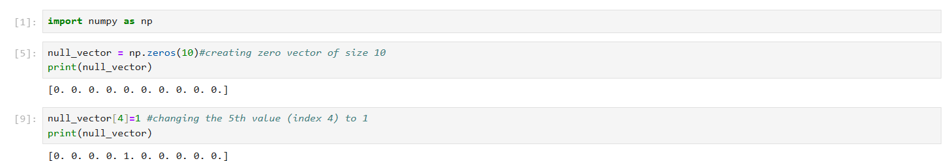

2. Ask user to input two numbers a, b. Write a program to generate a random array of shape (a, b) and print the array and avg of the array.
Screenshot
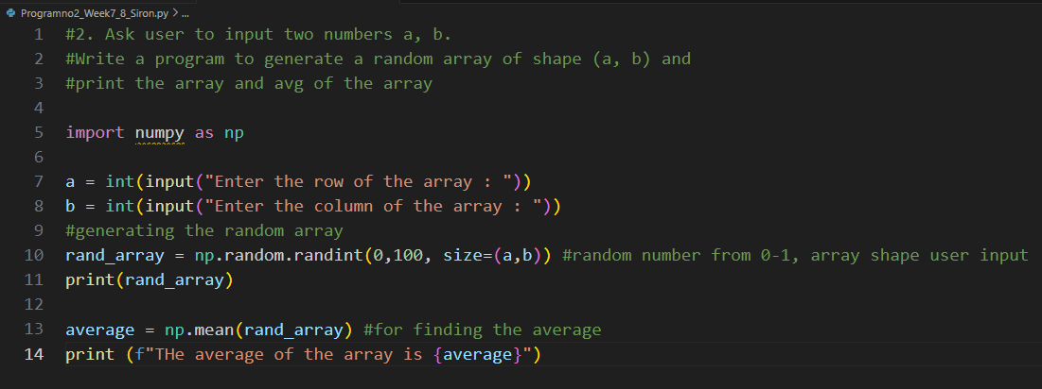
Output
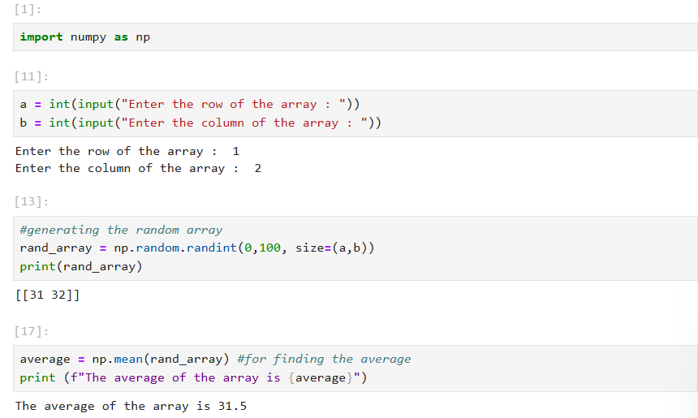
3. Create a vector of size 10 with values ranging from 0 to 1, both excluded.
Screenshot
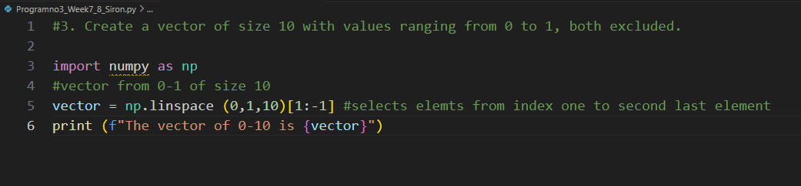
Output
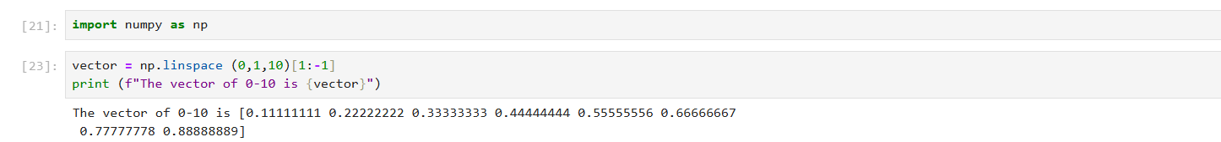

4. Can you create a identity matrix of shape (3,4). If yes write code for it.
Screenshot
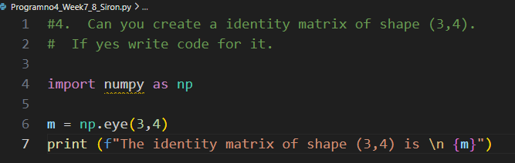

Output

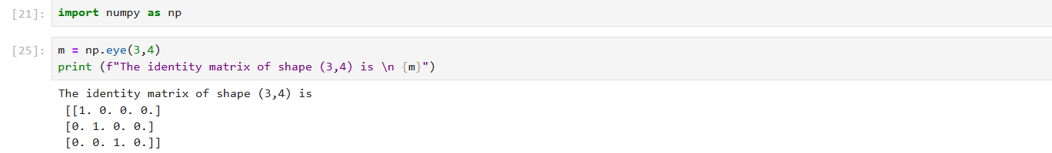
5. Create a 5x5 matrix with row values ranging from 0 to 4.
Screenshot
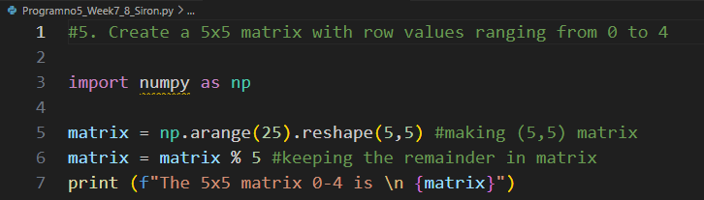
Output
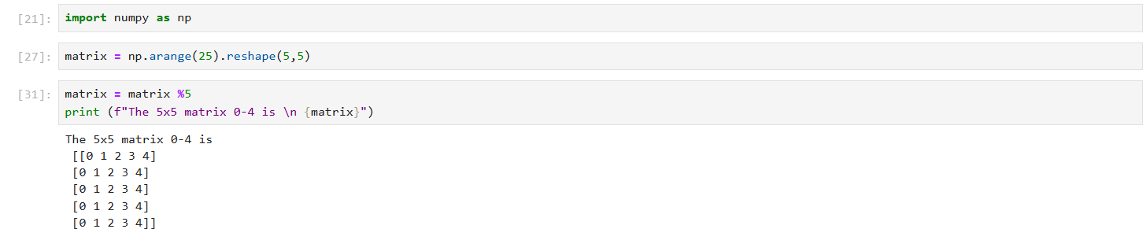

6.Write a program to input an array of numbers from the user (at least 10 elements in list), sort them and perform slicing operations to get elements between indexes such as 2-5, 5-8, 2-9. [15 marks]
Screenshot
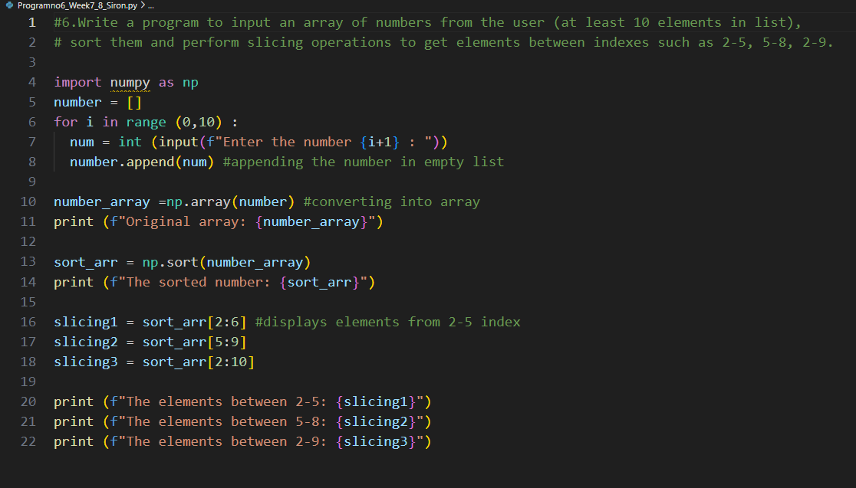

Output

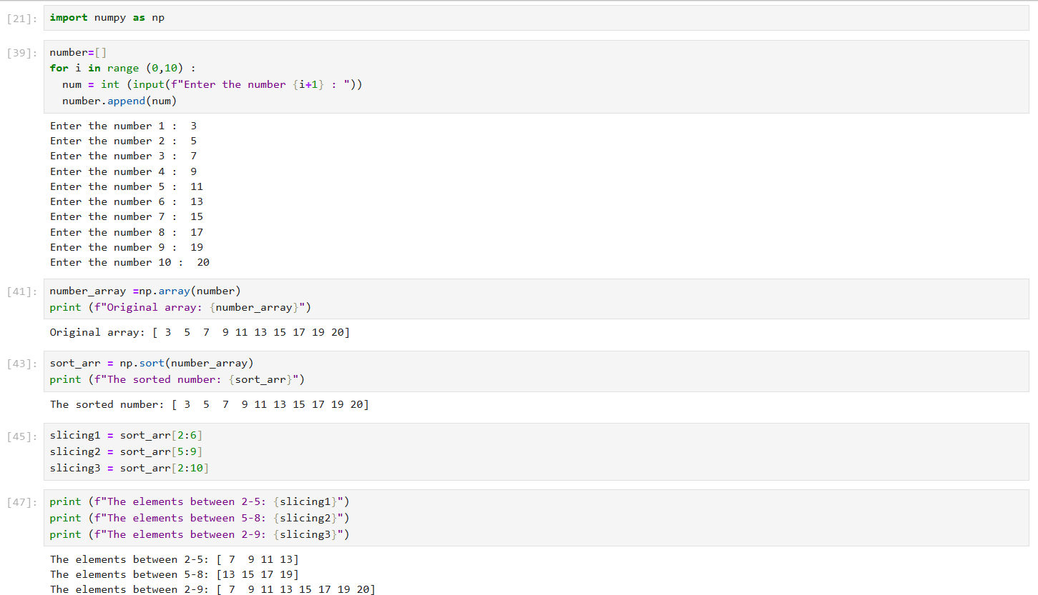

7. Create an array of random integer numbers as a numpy array, sort them and perform operations such as reshaping of the array into matrix of feasible dimensions. (e.g., if we have an array of 1 * 10, then we can reshape it into 2 * 5 or 5 * 2 matrix.) [Hint: Use the array of reshape (row * column)] [15 marks]
Screenshot
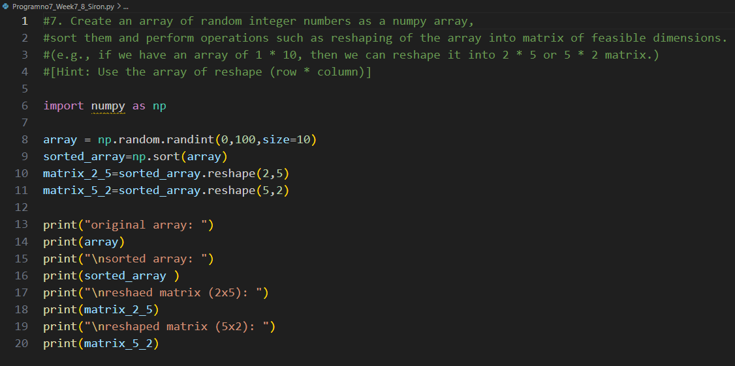
Output

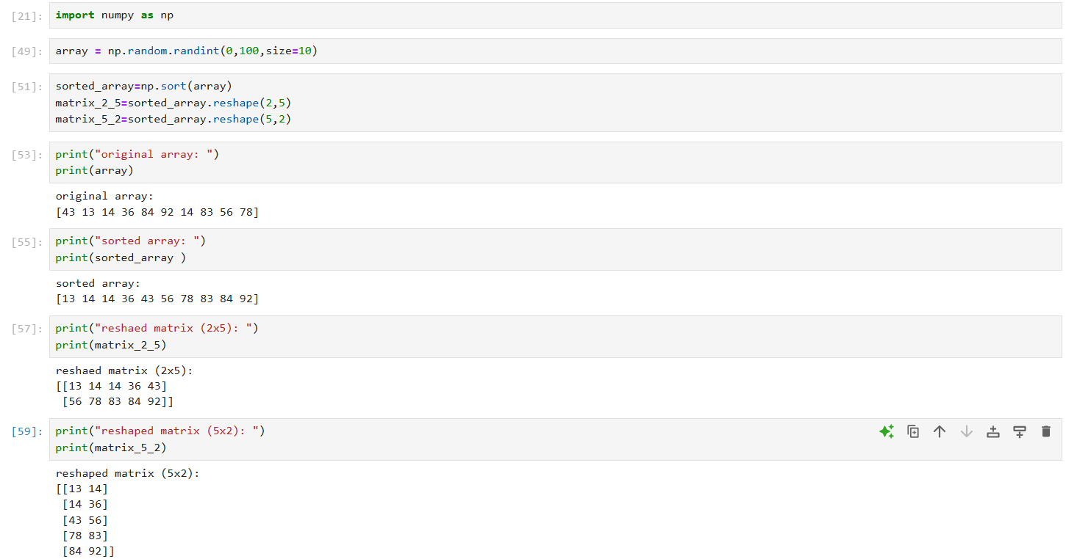

8. Write a Pandas program to add, subtract, multiple and divide two Pandas Series.
Screenshot
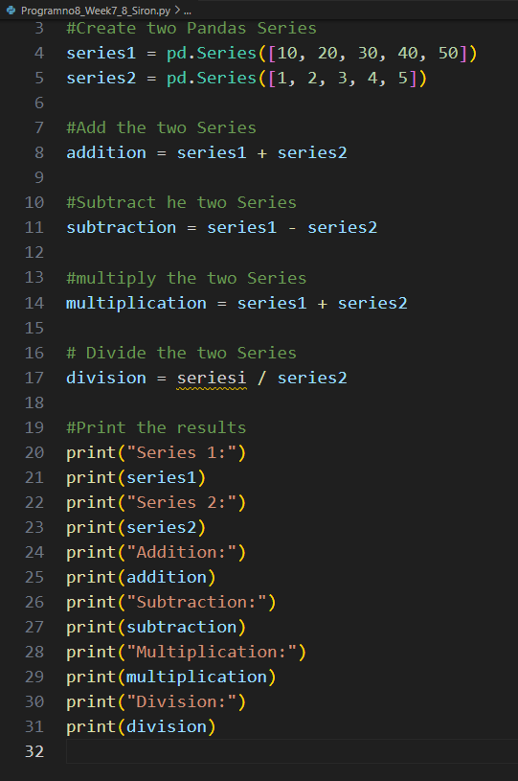

Output
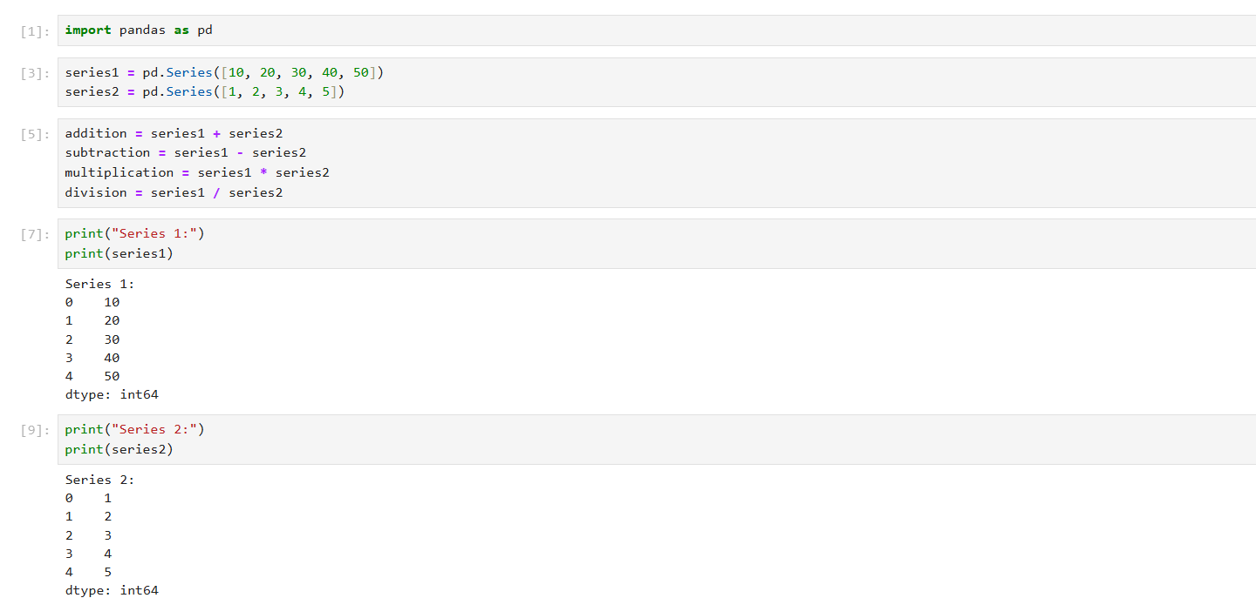
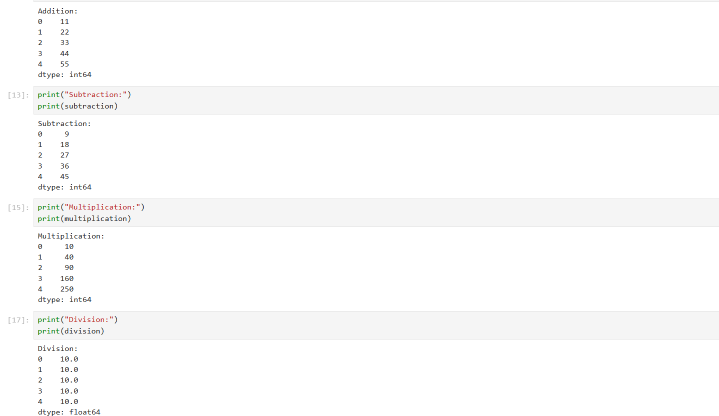
9. Given the table below, [10 marks / 1 each]

EmployeeID | Name | Department | Age | Salary | JoinDate | ExperienceYears
101 | John Smith | IT | 30 | 70000 | 2018-07-15 | 5
102 | Alice Brown | HR | 28 | 60000 | 2020-03-10 | 3
103 | Bob White | IT | 35 | 80000 | 2016-11-01 | 7
104 | Emma Green | Finance | 40 | 90000 | 2012-05-25 | 11
105 | Charlie Red | HR | 25 | 55000 | 2021-06-01 | 2
Output: 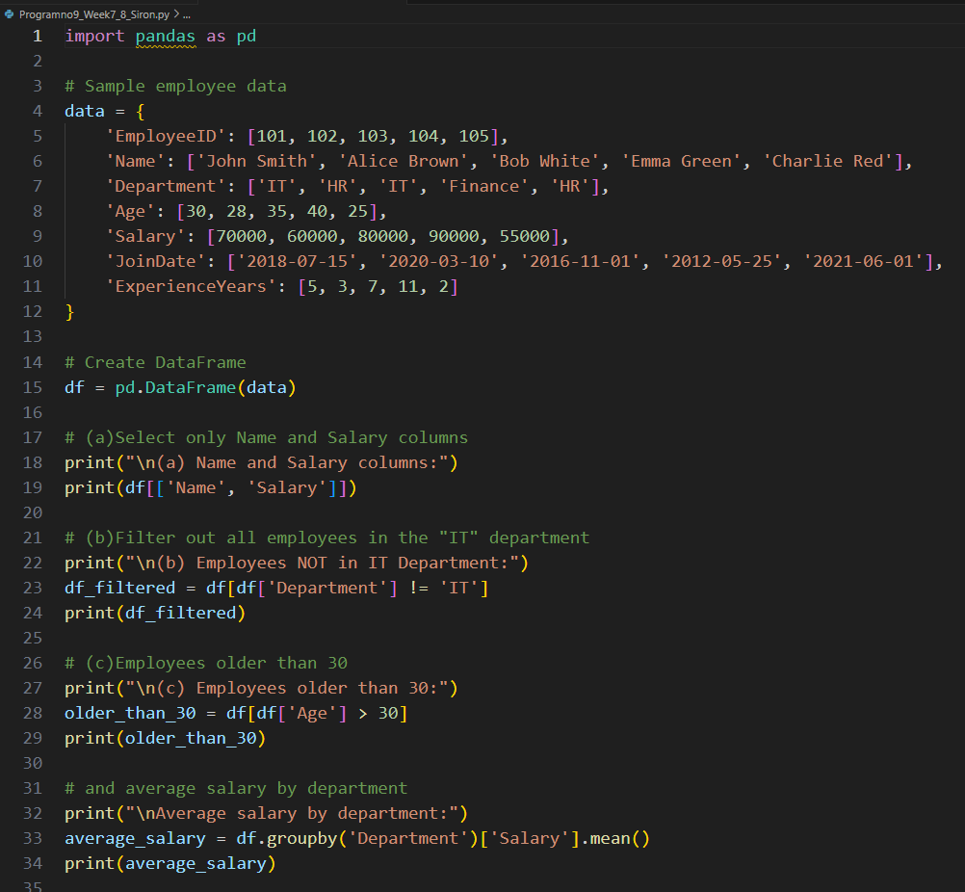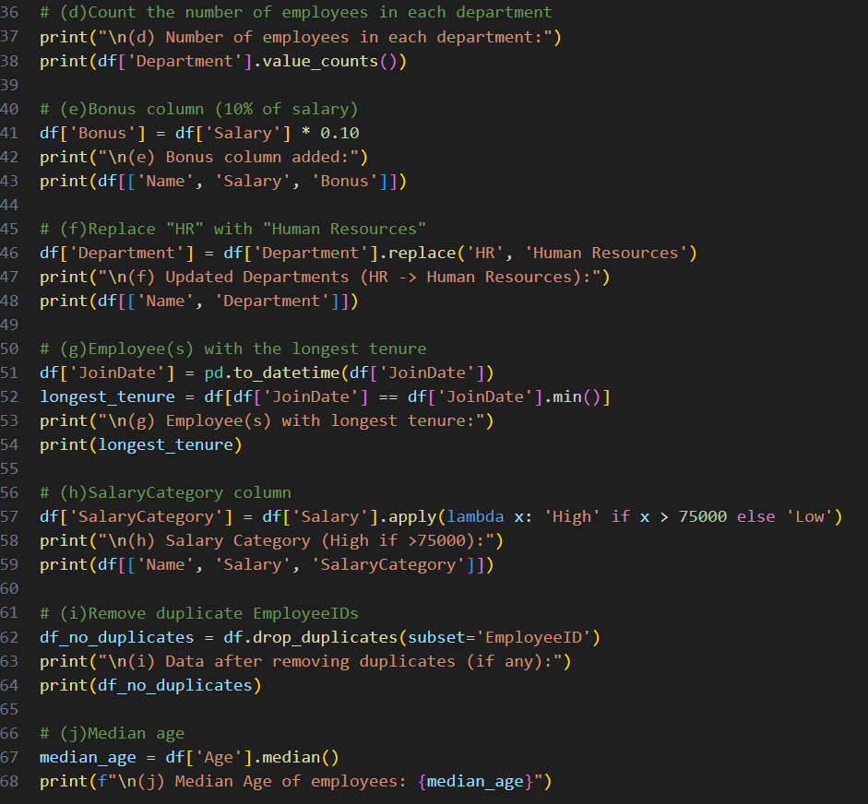
- Write a query to select only the Name and Salary columns.
Output: 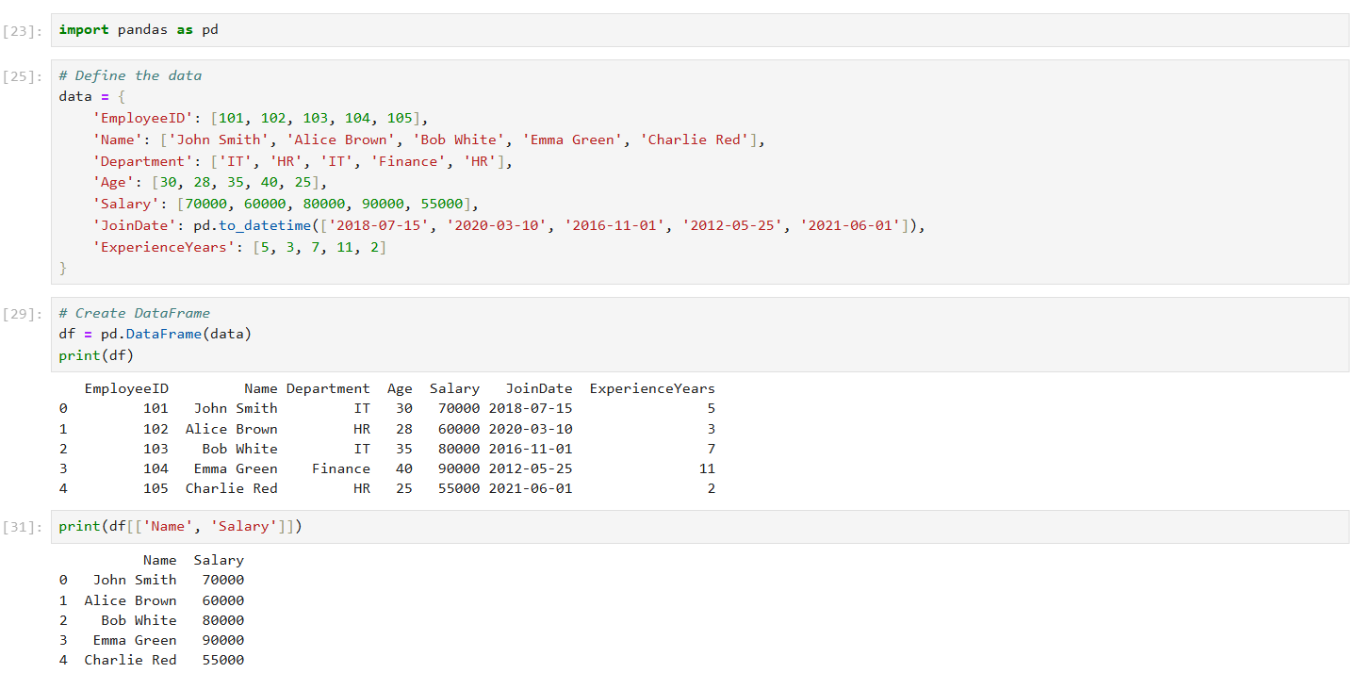
- How would you filter out all employees in the "IT" department?
Output: 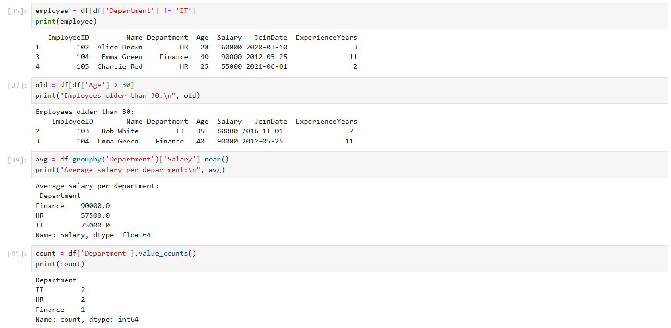
- Write code to select employees who are older than 30 and find the average salary of employees in each department.
Output: 
- Write code to count the number of employees in each department.
Output: 
- Add a new column Bonus which is 10% of each employee's salary.
Output: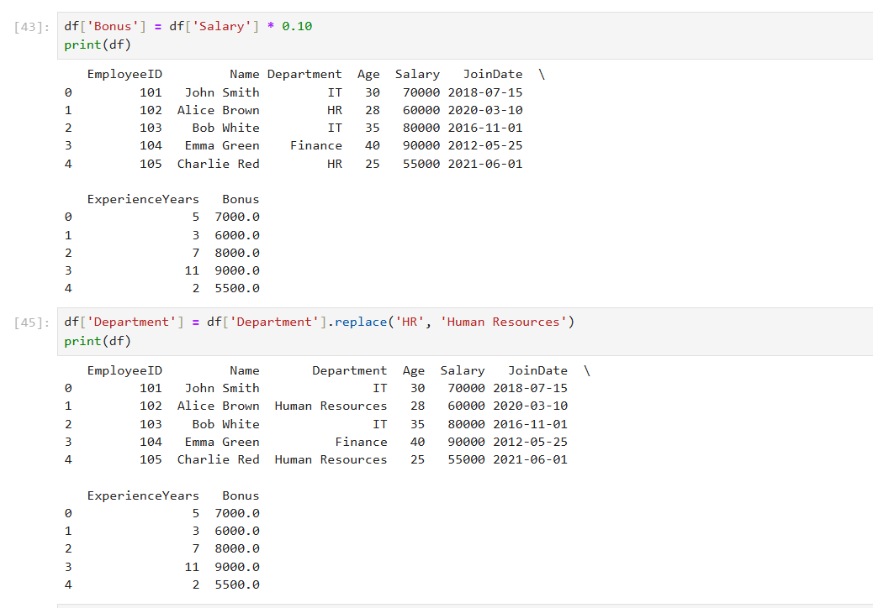
- Replace all occurrences of "HR" in the Department column with "Human Resources."
Output: 
- Find the employee(s) with the longest tenure (based on JoinDate).
Output: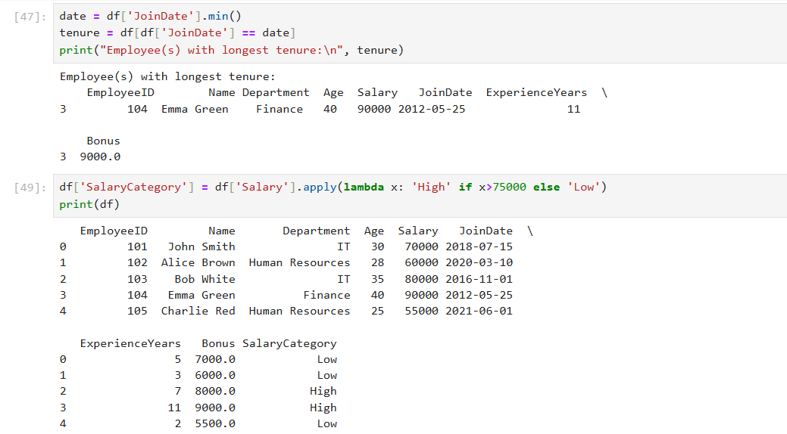
- Create a new column SalaryCategory where salaries above 75,000 are categorized as "High" and the rest as "Low."
Output: 
- Write a program to check if there are any duplicate EmployeeIDs and remove them if found.
Output: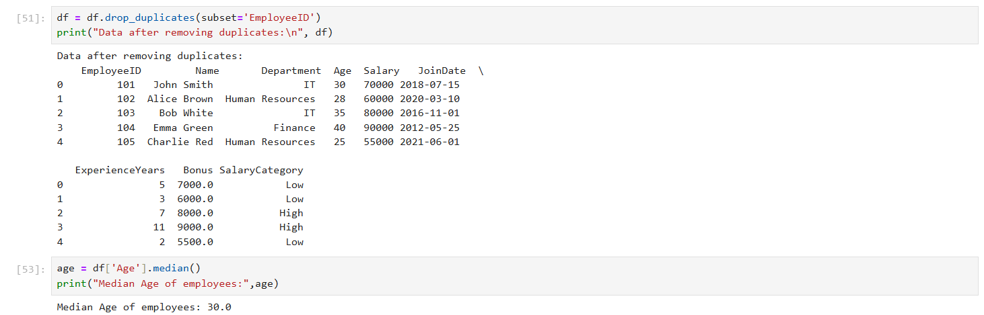
- Use Pandas to calculate the median Age of all employees.
Output: 

